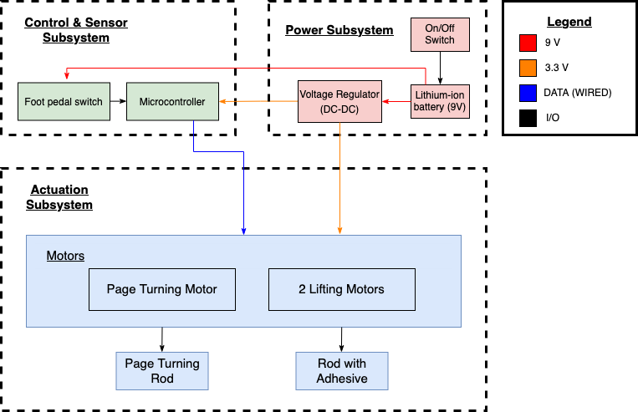

The power subsystem handles sending power to the rest of the components in the other two subsystems. The power subsystem includes a disposable 9V Lithium-Ion battery, a DC to DC voltage regulator, and an On/Off switch. The voltage regulator reduces the voltage needed to power the foot pedal, microcontroller and motors.